43.43: a) As in Ex.
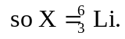
b) As in Ex. (43.41b), using so energy is absorbed in the reaction.
c) From Eq. (43.24): 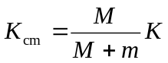
so
